**Modeling for the spam filter using the text mode HML**

**Introduction**

This note introduces how to learn a spam filter MTheory using a text mode HML.

Index

1. Installing the HML JAVA project 1

2. Importing a spam database into MySQL 2

3. Executing a text mode HML 2

4. Reasoning the spam filter MTheory using the GUI mode 5

## Installing the HML JAVA project

For this example, install the HML project, four projects edu.gmu.seor.prognos.unbbayesplugin.continous, cps, MEBN, and UnBBayes.

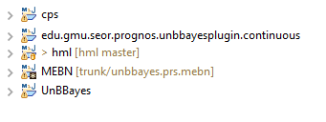

If successfully these are installed, we can see five projects as shown in the above figure.

## Importing a spam database into MySQL

The HML JAVA project includes a spam database.

By using “spamdatabase.sql” in the red box, we can create the spam database in MySQL.

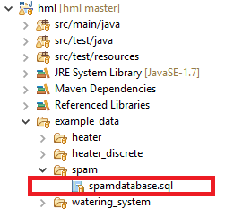

## Executing a text mode HML

To execute HML, use the class “Learning_test_for_spam.java” file in the red box in the following figure.

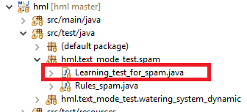

To access the relational DB, set the root and password of the local DB as shown in the red box in the following figure.

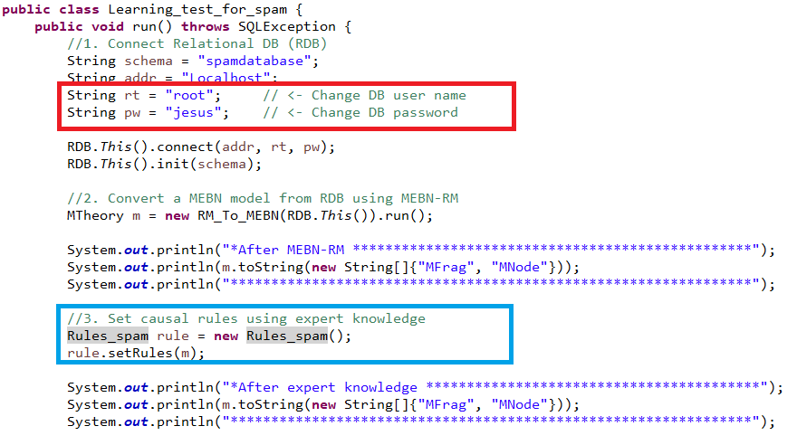

The rules, causal relationships, can be set by using the class Rules_spam in the blue box in the above figure.

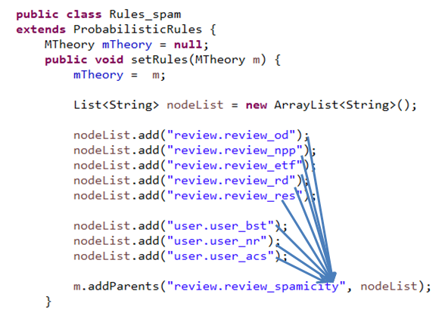

This example has a simple rule as shown the above figure. The attribute spamicity in the table review depends on the attributes od~res in the table review and the attributes bst~acs in the table user.

After executing the class “Learning_test_for_spam.java”, we can find the file “learnedMEBN.ubf”.

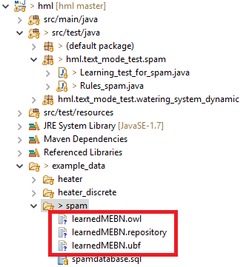

## Reasoning the spam filter MTheory using the GUI mode

To run the learned MTheory, use the class “UnBBayesMainDelegator.java”.

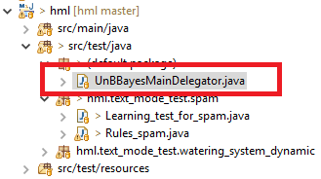

And load the file “learedMEBN.ubf”, and then we can see the MTheory.

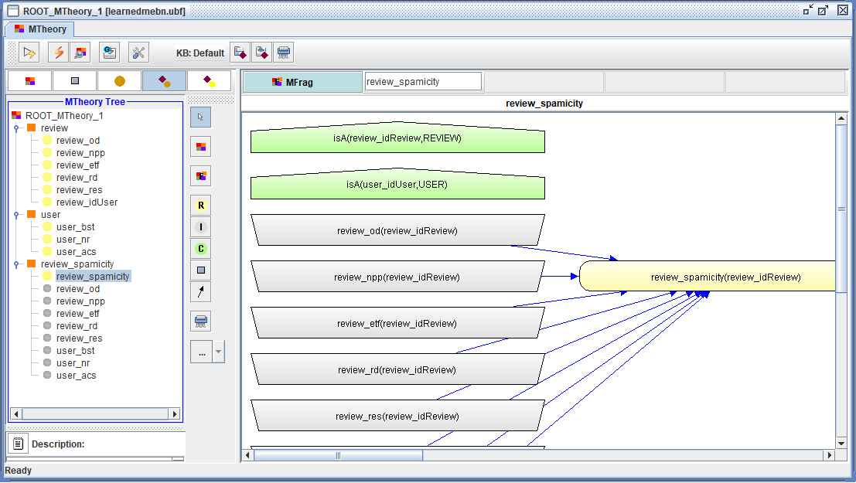

Add entity instances (for review and user) by using the fourth button as shown the red box in the following figure.

For this, click the entity type REVIEW in the blue box in the following figure. And then put an entity instance name (e.g., r1) in the editing box “Name:”. And then click the button “+”.

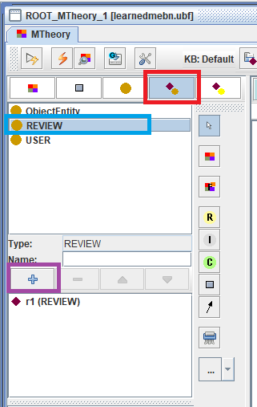

In the same way, we can add the user entity instance as shown the following figure.

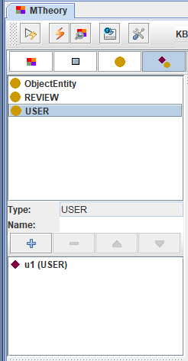

To query the node “review_spamicity”, click the button “Execute Query”.

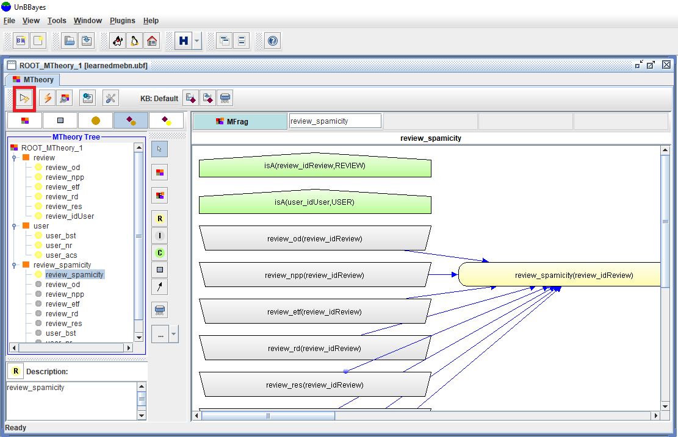

Select the item “review_spamicity”.

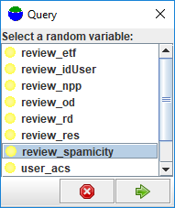

Select the entity instance r1 for REVIEW_label.

Then click the button “Query”.

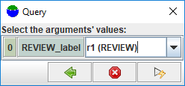

Then, we can see a reasoned SSBN from the MTheory.

